CERBERUS
SOLAR MIRROR
Modular Imagery Routing for Reusable Object Reconstruction
A Routable Offline Asset Architecture for System Imagery, Composite Shapes, General Images, and Persistent Visual Reconstruction
CORE SYSTEM STATEMENT
SOLAR MIRROR is the offline visual-material routing and reconstruction layer associated with SOLAR. It gives semantic identities persistent routes into reusable imagery and reconstructable visual components without requiring the semantic Base to store or own the underlying files.

FOUNDATIONAL COMPRESSION
Find the meaning. Route to the material. Reuse the parts. Reconstruct the object.
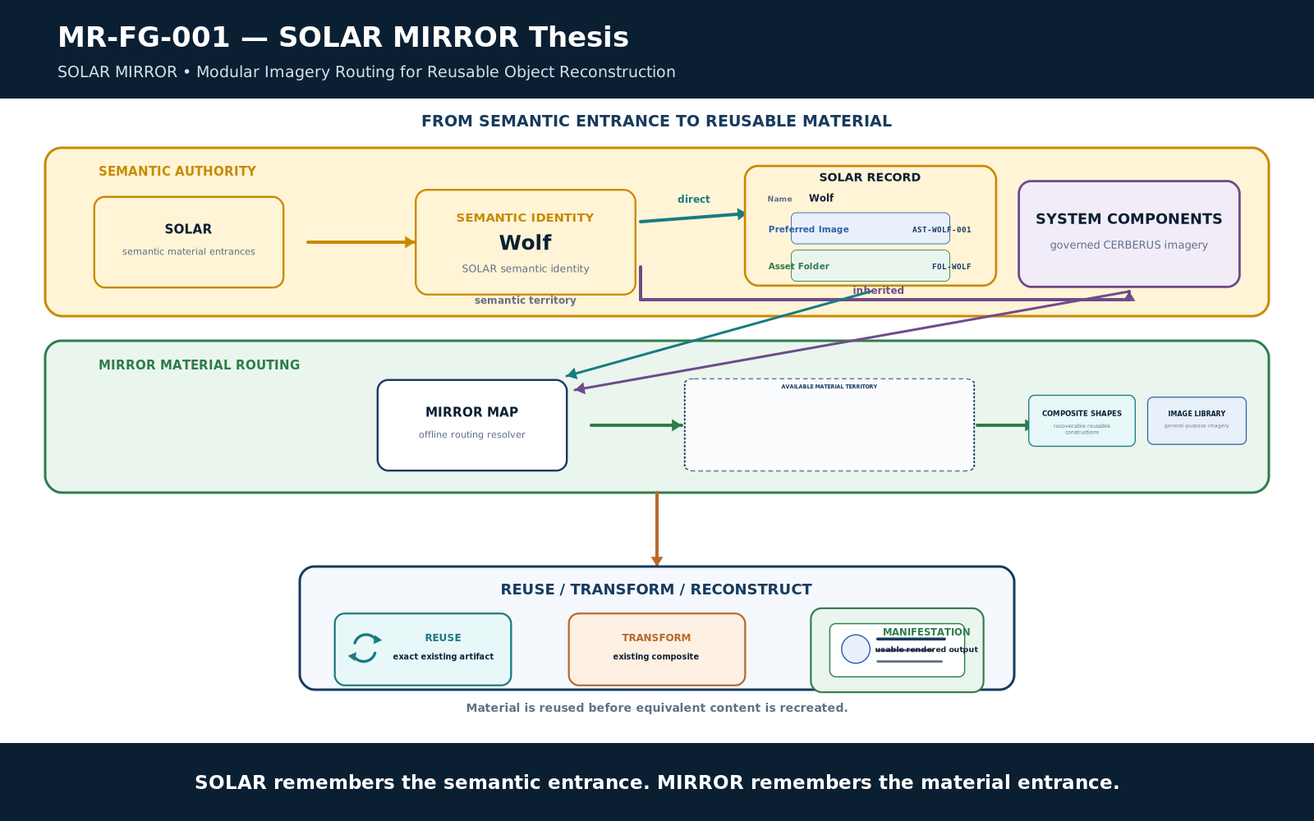
Figure 1. SOLAR MIRROR thesis.
Meaning resolves to routes; routes resolve to reusable material; reusable material supports reconstruction.
Version 0.1 | 24 August 2026 | Pass 8 Verified Release

Document Control
Control | Value
Document | CERBERUS SOLAR MIRROR - Modular Imagery Routing for Reusable Object Reconstruction
Version | 0.1
Date | 24 August 2026
Status | Pass 8 Verified Release
System role | Offline visual-material routing and reconstruction layer associated with SOLAR
Direct SOLAR fields | Preferred Image; Asset Folder
Offline domains | SOLAR Mirror; System Components; Composite Shapes; Image Library; MIRROR_MAP
Figure program | 18 approved Figure Contracts; 18 Compound Constructs; 18 publication renders
Primary boundary | CERBERUS owns semantic identity and meaning; MIRROR owns routable offline material organization and reusable artifacts.

Executive Summary
SOLAR MIRROR extends the CERBERUS semantic environment into an offline material environment. SOLAR already gives language persistent routes into governed semantic territory. MIRROR adds a parallel material entrance: a SOLAR record may directly identify one Preferred Image and one Asset Folder, while the same record may also inherit imagery through its existing links to BIGFOOT, BOSS, Display, Stack structures, and other governed systems.
The architecture deliberately separates three things that are often collapsed: the semantic object, the reusable visual asset, and the physical file location. A wolf image is not the semantic identity Wolf, and a file path is not the image itself. MIRROR connects those layers through persistent routes so semantic identities can discover material without storing binaries in the Base or hard-coding machine-specific filesystem paths.
The offline library is assembled into distinct material regions: a SOLAR mirror for semantic entrances, System Components for governed CERBERUS imagery, Composite Shapes for recoverable reusable constructions, and a general Image Library for unrestricted imagery. MIRROR_MAP resolves logical route identities to the current physical folder graph. Composite and rigged assets preserve construction so known objects can be transformed and reconstructed rather than repeatedly regenerated.
PRIMARY ARCHITECTURAL LAW
Semantic Identity is not Visual Asset, and Visual Asset is not File Location. MIRROR joins these layers without collapsing their ownership.

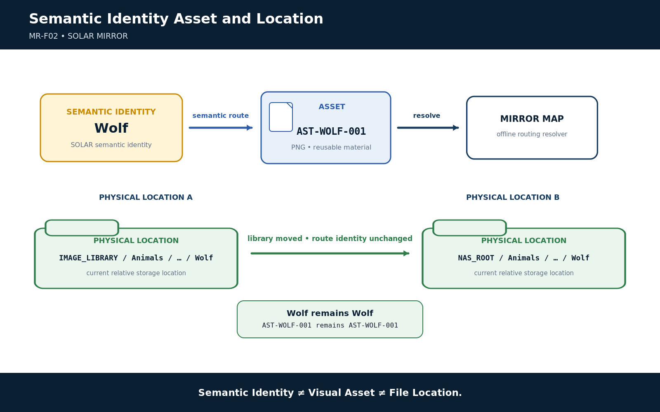
Figure 2. Semantic identity, asset, and physical location.
Semantic Identity, Visual Asset, and File Location remain separate identities.

Section Index
Part | Section
Part 1 | From Semantic Territory to Material Territory
Part 2 | How MIRROR Is Assembled
Part 3 | How MIRROR Reconstructs
Part 4 | How MIRROR Grows and Remains Governed
Appendix A | Normative MIRROR Laws
Appendix B | Reconstruction Tests
Appendix C | Figure Index and Implementation Handoff

Reading Order
Part 1 establishes the semantic/material boundary, direct SOLAR fields, inherited routes, and the meaning of available material territory. Part 2 defines the offline folder architecture, MIRROR_MAP, System Components, Composite Shapes, and general imagery. Part 3 explains identity-first retrieval, flattened/composite/rigged classes, layered reconstruction, reuse, and worked examples. Part 4 defines human modification, material accretion, ownership boundaries, lifecycle expectations, and the handoff to the later OctoGroove integration paper.

PART 1 - From Semantic Territory to Material Territory
SOLAR provides semantic entrances. MIRROR provides persistent material entrances without becoming semantic authority.

1. The Repeated-Asset Problem
A semantic system can precisely identify an object and still repeatedly recreate its visual representation. Without persistent material routing, each new document, interface, scene, or technical figure may redraw shapes that already existed, regenerate images that were previously accepted, or search a large filesystem without knowing which artifacts are semantically relevant.
SOLAR MIRROR addresses that inefficiency by making approved visual material persistently routable. The architecture does not require every concept to have an image. It provides a governed way to discover material when material exists, to preserve reusable construction when useful, and to create new material only when a genuine gap remains.

2. Definition of SOLAR MIRROR
SOLAR MIRROR is the offline visual-material routing and reconstruction layer associated with SOLAR. It extends SOLAR with optional direct routes to a Preferred Image and an Asset Folder, combines those routes with imagery exposed through existing CERBERUS graph relationships, and resolves the resulting territory into reusable system components, composite shapes, general imagery, and reconstructable layered assets without transferring semantic ownership away from CERBERUS.
SHORT FORM
SOLAR remembers where meaning begins. MIRROR remembers where the material is.

3. Semantic Identity, Visual Asset, and File Location
Figure 2. Semantic identity, asset, and physical location.
Semantic Identity, Visual Asset, and File Location remain separate identities.
The three identities must remain separable. Semantic identity answers what the governed thing is. Asset identity answers which reusable material artifact is being referenced. File location answers where that artifact currently resides. Moving a library folder should not mutate the semantic record, and changing a preferred image should not redefine the governed meaning of the concept.
This separation is what makes MIRROR portable. It also prevents accidental semanticization of files: two records can share one image without becoming the same concept, and one record can expose many different visual resources without fragmenting its semantic identity.

4. SOLAR as the Semantic Entrance
SOLAR remains the lexical and semantic entry surface. A human or AI can begin with ordinary language such as Wolf, Tree, Scalar, Target, or Week and resolve into the registered CERBERUS territory already connected to that term. MIRROR does not replace this role. It extends the reachable territory from meaning into reusable offline material.
This yields a paired model: SOLAR answers where to enter the semantic graph, while MIRROR answers where to enter the associated material graph. The two graphs remain linked but independently governed.

5. The Two Direct SOLAR Fields
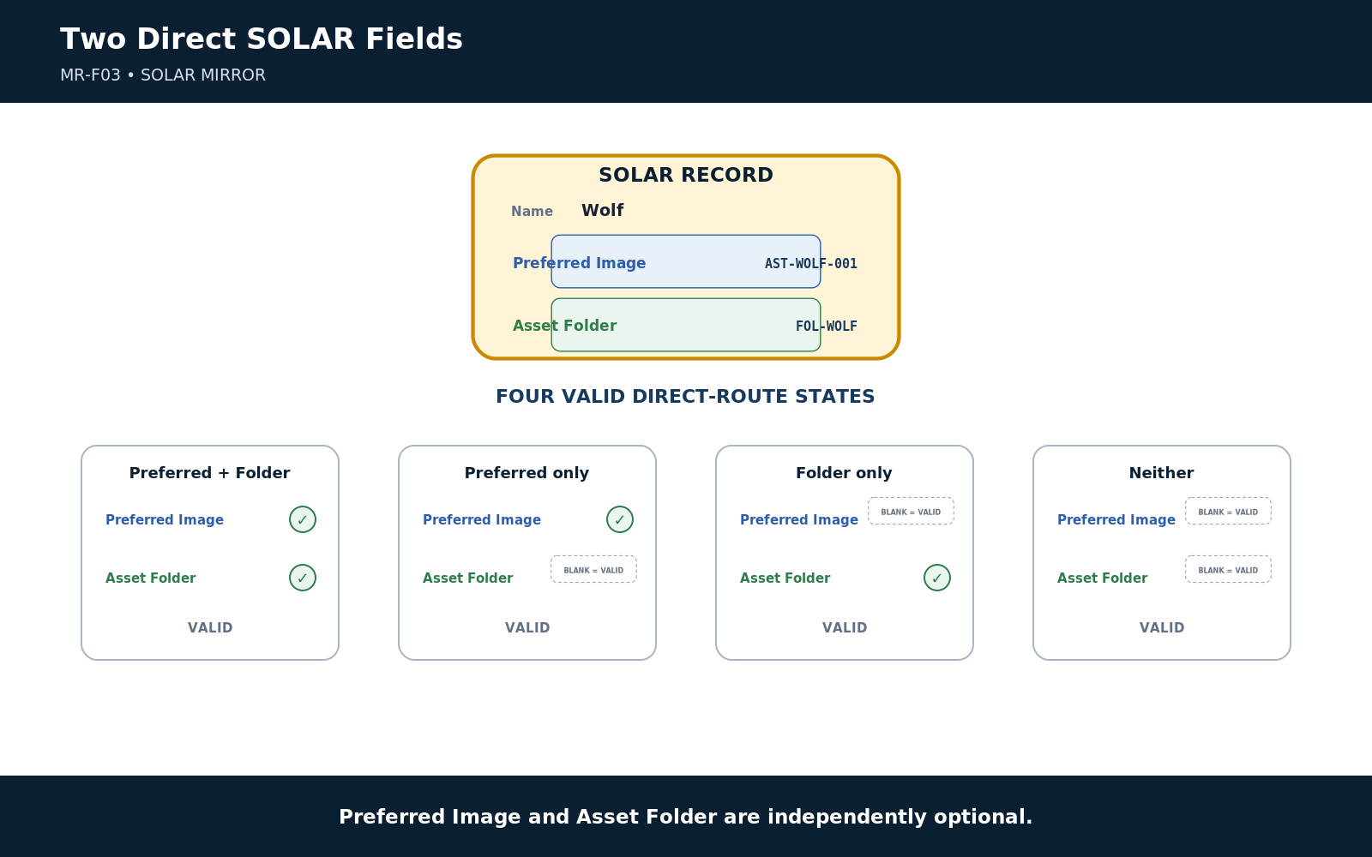
Figure 3. Two direct SOLAR fields.
Preferred Image and Asset Folder are independent optional direct routes; blank is valid.

Preferred Image
Preferred Image is an optional direct route to one default visual representation of the SOLAR record. It exists for cases where a consumer needs an immediate representative visual without searching the broader asset territory. Preferred means shortest default route, not exclusive truth.

Asset Folder
Asset Folder is an optional direct route into the concept's offline material territory. The territory may be simple or arbitrarily complex. It can contain photographs, SVGs, layered illustrations, rigged composites, textures, references, generated candidates, manifests, or formats introduced later. SOLAR only needs to know where the territory begins.

6. Four Valid Direct-Route States
Preferred Image | Asset Folder | Interpretation
Present | Present | Immediate default visual plus explorable material territory.
Present | Blank | One direct default visual is registered; no direct folder territory is registered.
Blank | Present | No single default is declared; a broader material territory is available.
Blank | Blank | No direct MIRROR route is registered. Inherited material may still be reachable through CERBERUS.

BLANK ROUTE LAW
Blank is a valid governed state. It means no direct route has been registered, not that the concept is invalid or visually impossible.

7. Direct and Inherited Material Routing
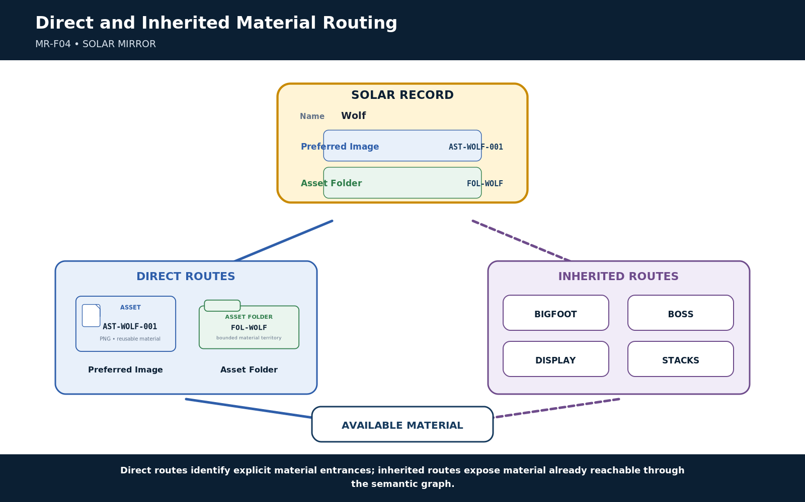
Figure 4. Direct and inherited material routing.
Direct SOLAR routes and inherited CERBERUS routes contribute to the same available material horizon.
Direct routes are explicit material entrances recorded on the SOLAR record. Inherited routes arise from the existing semantic graph: a SOLAR record can already link to BIGFOOT, BOSS, Display, Stack symbols, and other registered structures, and those structures may expose their own assets. Both mechanisms contribute to the material horizon available to the current task.
This distinction prevents forced modeling. Wolf does not need to become a formal system component merely because the library contains wolf imagery. At the same time, a BitWord can automatically expose constituent system imagery through BIGFOOT without requiring a custom Wolf-style folder route.

8. Available Material Territory
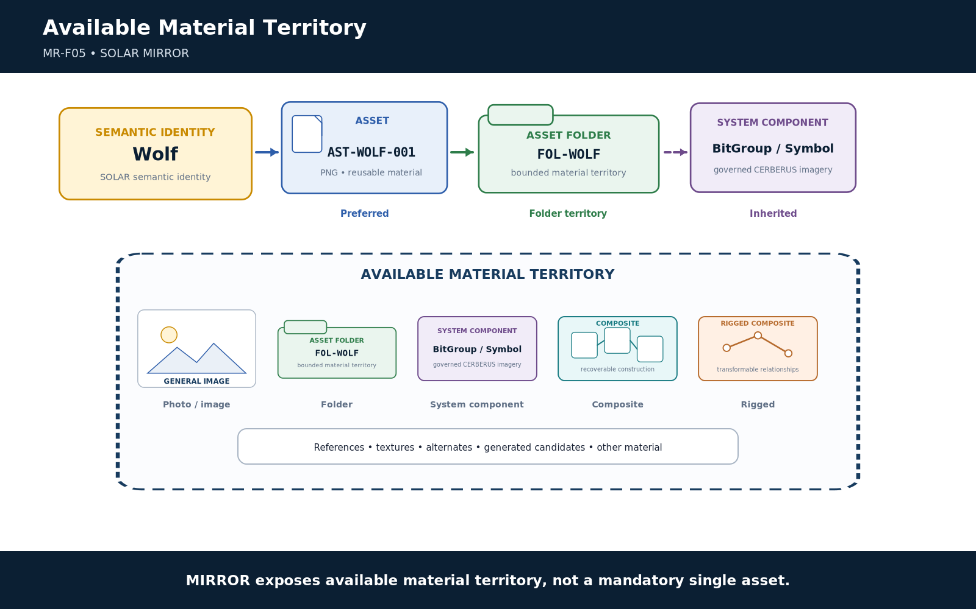
Figure 5. Available material territory.
MIRROR exposes heterogeneous material territory rather than forcing one mandatory file.
MIRROR returns material territory rather than a single mandatory asset. The territory can contain a Preferred Image, folders, exact system components, flattened images, reusable composites, rigged composites, textures, reference material, and related artifacts. The consumer decides which subset is appropriate for the current reconstruction.
MATERIAL TERRITORY
Availability is broader than requirement. MIRROR shows what can be reached; the task determines what is actually needed.

PART 2 - How MIRROR Is Assembled
The filesystem separates semantic entrances, governed system imagery, reusable constructions, general imagery, and route resolution.

9. The Offline MIRROR Root
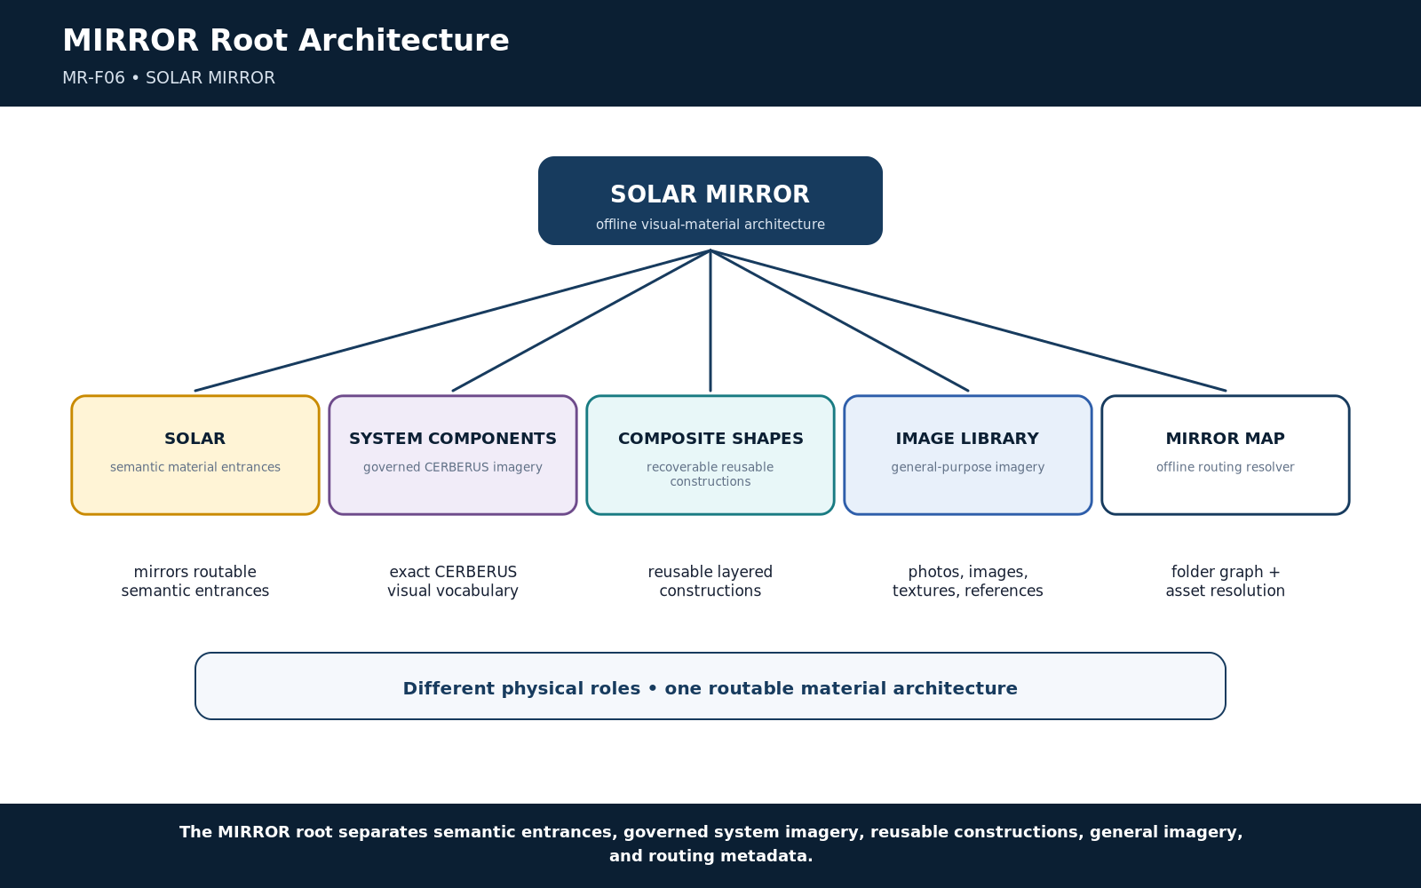
Figure 6. MIRROR root architecture.
The root separates semantic entrances, governed system imagery, reusable constructions, general imagery, and routing metadata.
The conceptual root is intentionally small: SOLAR, SYSTEM_COMPONENTS, COMPOSITE_SHAPES, IMAGE_LIBRARY, and MIRROR_MAP.xlsx. Each region has a different responsibility. The separation keeps the library navigable while allowing each region to become arbitrarily deep internally.
Root Region | Responsibility
SOLAR | Offline material entrances corresponding to SOLAR semantic territory.
SYSTEM_COMPONENTS | Governed imagery representing registered CERBERUS structures.
COMPOSITE_SHAPES | Recoverable reusable constructions assembled from addressable components.
IMAGE_LIBRARY | General-purpose imagery, photographs, textures, references, and unrestricted visual material.
MIRROR_MAP.xlsx | Offline resolver from logical route or asset identity to the current physical folder graph.

10. The SOLAR Mirror
The SOLAR branch mirrors routable semantic territory rather than duplicating every file. A semantic entrance may resolve to a Preferred Image, an Asset Folder, inherited material, or no direct material at all. The mirror is therefore an addressable correspondence between semantic and material territory, not a requirement that every SOLAR record physically contain an image.

11. Folder Opacity
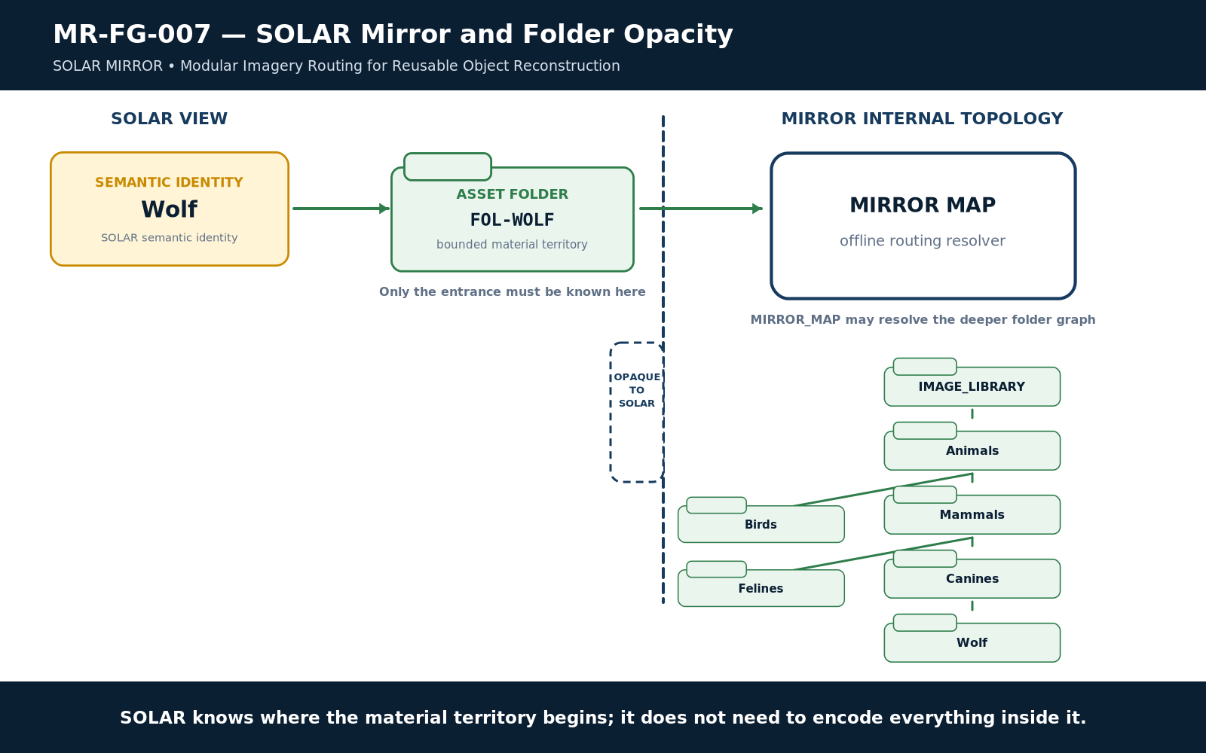
Figure 7. SOLAR Mirror and folder opacity.
SOLAR knows where material territory begins without encoding the territory's internal filesystem topology.
A SOLAR Asset Folder route terminates at the material-territory entrance. MIRROR_MAP and the filesystem can know that the territory contains Animals/Mammals/Canines/Wolf/Rigged/..., but SOLAR does not need to encode that entire path topology. This keeps the Base stable while the offline library evolves.
FOLDER OPACITY LAW
SOLAR SHALL resolve the entrance to an offline asset territory without requiring knowledge of the territory's complete internal filesystem topology.

12. System Components
SYSTEM_COMPONENTS contains visual artifacts representing formal CERBERUS structures. Likely regions include BIGFOOT Bits, BitGroups, and BitWords; BOSS symbols; stack symbols; DARTBOARD components; TIME visual tokens; interface components; operators; and other governed imagery. The Base remains authoritative for what these structures mean. MIRROR stores or routes to their reusable material representations.
System Components should favor exact reuse. If a canonical BitGroup SVG already exists, downstream work should retrieve that artifact rather than reconstruct a visually similar approximation from memory.

13. BIGFOOT Asset Traversal
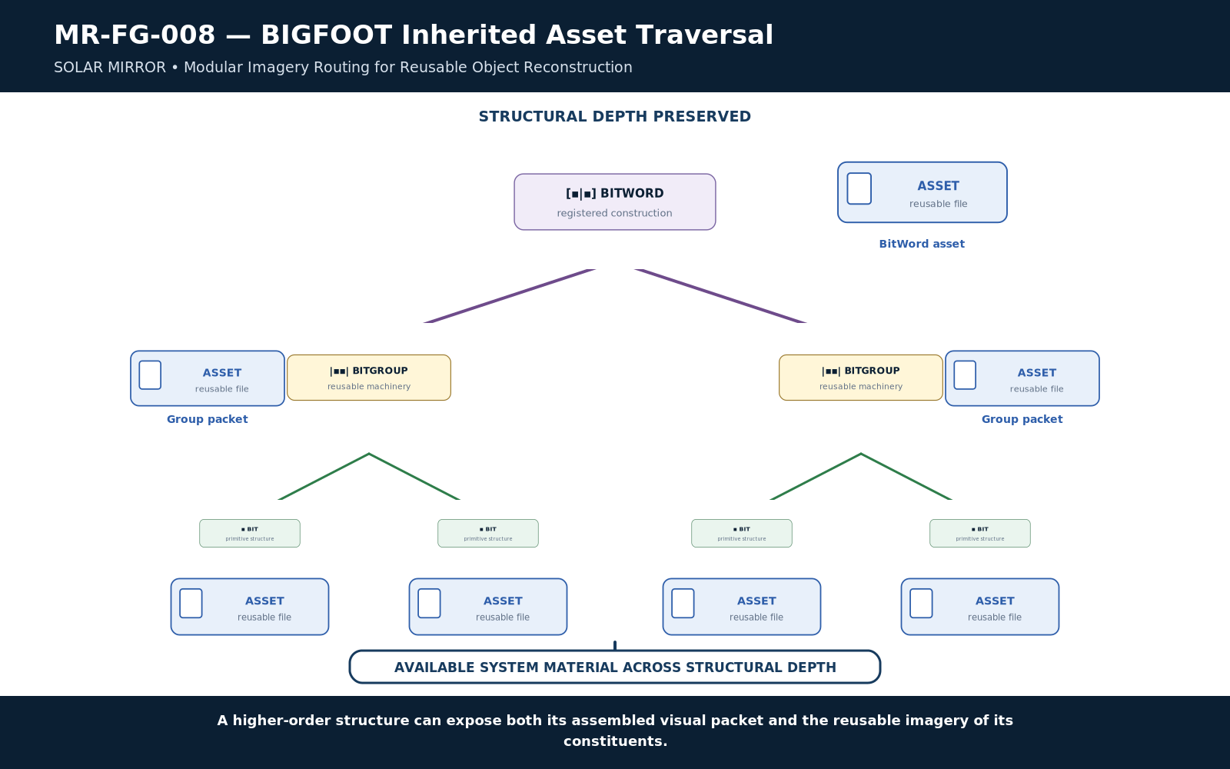
Figure 8. BIGFOOT inherited asset traversal.
Higher-order BIGFOOT structures can expose both assembled imagery and reusable imagery from their constituents.
BIGFOOT already provides a compositional graph: BitWord to BitGroups to Bits. MIRROR can use that graph to expose material at multiple structural depths. A BitWord may have its own assembled asset; each BitGroup may have an assembled packet; and constituent Bits may expose primitive assets. These resources remain simultaneously discoverable.
The result is visual level-of-detail without information loss. A high-level reconstruction can reuse an assembled BitGroup token, while an inspection or rebuild can descend to exact constituent Bits when necessary.

14. Many-to-Many Asset Binding
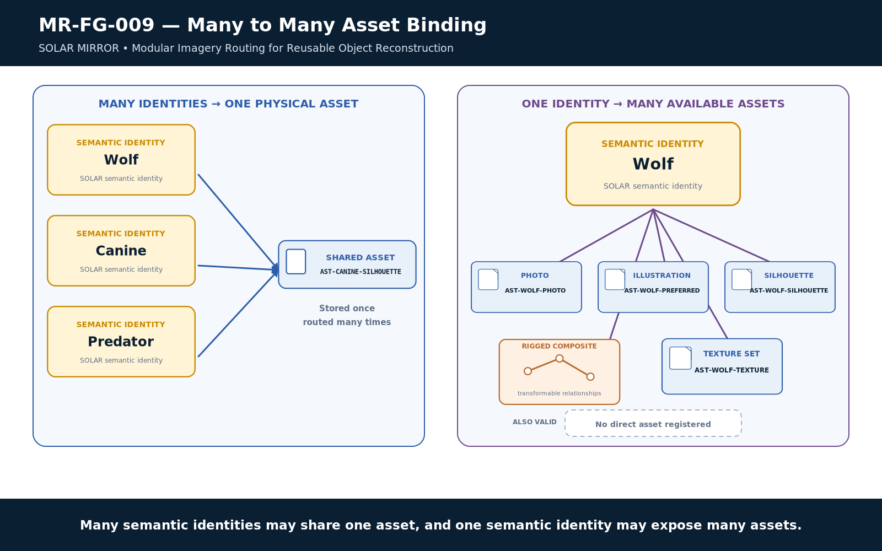
Figure 9. Many-to-many asset binding.
Many semantic identities may share one asset, and one semantic identity may expose many or no assets.
Semantic objects and assets do not have a one-to-one relationship. Wolf, Canine, and Predator may legitimately route to one shared silhouette. Conversely, Wolf may expose a preferred illustration, a photograph, a rigged composite, anatomy references, and textures. A semantic object may also expose no direct imagery at all.
OBJECT, ASSET, FILE
One object may route to many assets. One asset may serve many objects. One conceptual asset may also have multiple physical file variants.

15. Composite Shapes
COMPOSITE_SHAPES contains reusable constructions whose internal organization remains recoverable. A Composite can represent a diagram cluster, calendar assembly, tree, vehicle, animal, interface panel, building facade, or any other object assembled from separately addressable visual components. Composition may recurse: one Composite can contain System Components, general imagery, or other Composites.
The defining criterion is not visual complexity. It is recoverable construction. A simple three-part arrow assembly can be a Composite if those parts remain addressable; a photorealistic JPEG is still flattened if its internal construction is not recoverable.

16. General Image Library
IMAGE_LIBRARY is the unrestricted visual reservoir. It may contain Animals, Plants, Fungi, Rocks, Minerals, People, Objects, Buildings, Vehicles, Landscapes, Food, Textures, historical references, fantasy material, photographs, scans, AI-generated imagery, or any other useful visual source. Its folder taxonomy is for practical storage, not semantic authority.
The physical taxonomy does not need to reproduce CERBERUS. A wolf photograph can live once under a sensible physical folder and be reachable from multiple SOLAR concepts through persistent routes.

17. MIRROR_MAP as Offline Resolver
MIRROR_MAP is the routing intelligence that resolves logical route identities to physical locations. It is not a second semantic ontology. Its job is to answer operational questions such as: Where is Asset X? Which folder contains Route Y? Which files realize this conceptual asset? Which components belong to this Composite?
Logical View | Minimum Responsibility
Folder Graph | Folder identity, parent relationship, and relative location.
Asset Index | Asset identity, containing folder, physical file variant, format, and status.
Composition Graph | Composite identity and the constituent assets or nested composites required to reconstruct it.

18. Physical Location Independence
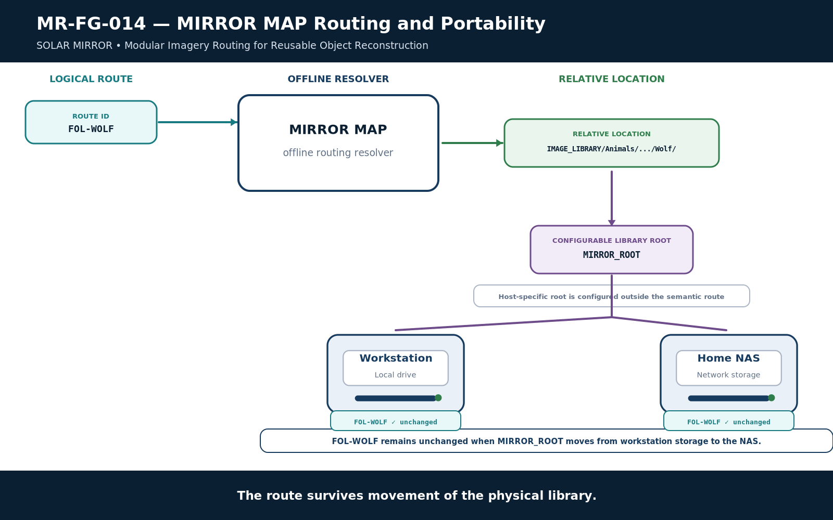
Figure 14. MIRROR_MAP routing and portability.
Logical MIRROR routes remain stable even when the physical storage root changes.
A route such as FOL-WOLF should survive migration from a laptop to a NAS, external drive, new workstation, or future storage system. MIRROR_MAP combines a configurable library root with relative routes, so machine-specific absolute paths do not leak into SOLAR as permanent architecture.
PORTABILITY PRINCIPLE
The Base should know the route identity, not the machine's accident of storage.

19. Asset Formats and Variants
MIRROR is format-tolerant. A conceptual asset may be realized as SVG, PNG, WebP, layered artwork, a 3D file, a texture set, a spreadsheet manifest, or other future formats. The architecture should preserve the distinction between the conceptual reusable asset and its physical variants so a new derivative can be added without changing every semantic route.

20. Material Ownership Boundary
Layer | Owns | Does Not Own
CERBERUS / SOLAR | Semantic identity, lexical routes, meaning, governed relationships. | Physical binary storage and filesystem topology.
MIRROR | Offline material organization, reusable artifacts, composite resources, physical routing metadata. | The semantic truth represented by those artifacts.
MIRROR_MAP | Resolution from logical material routes to current physical locations. | Domain semantics or authoritative business rules.

PART 3 - How MIRROR Reconstructs
Resolve identities first, retrieve only the required material, and preserve reusable construction wherever it creates future value.

21. Identity-First Material Resolution
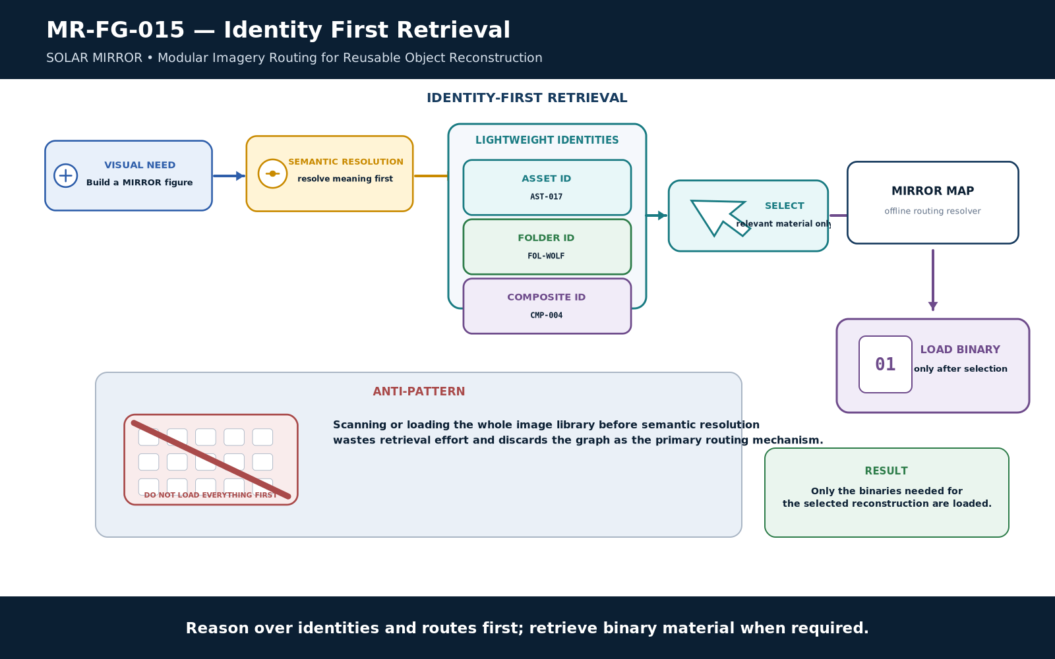
Figure 15. Identity-first retrieval.
Reason over identities and routes first; retrieve binaries only when reconstruction requires them.
A large visual library should not require an AI to load or visually scan every binary file before reasoning. The preferred sequence is semantic resolution, lightweight asset/folder/composite identity selection, MIRROR_MAP resolution, and only then retrieval of the binaries actually needed for reconstruction.
IDENTITY-FIRST RETRIEVAL LAW
Reason over identities and routes first; retrieve binary material when reconstruction requires it.

22. Visual Reconstruction Classes
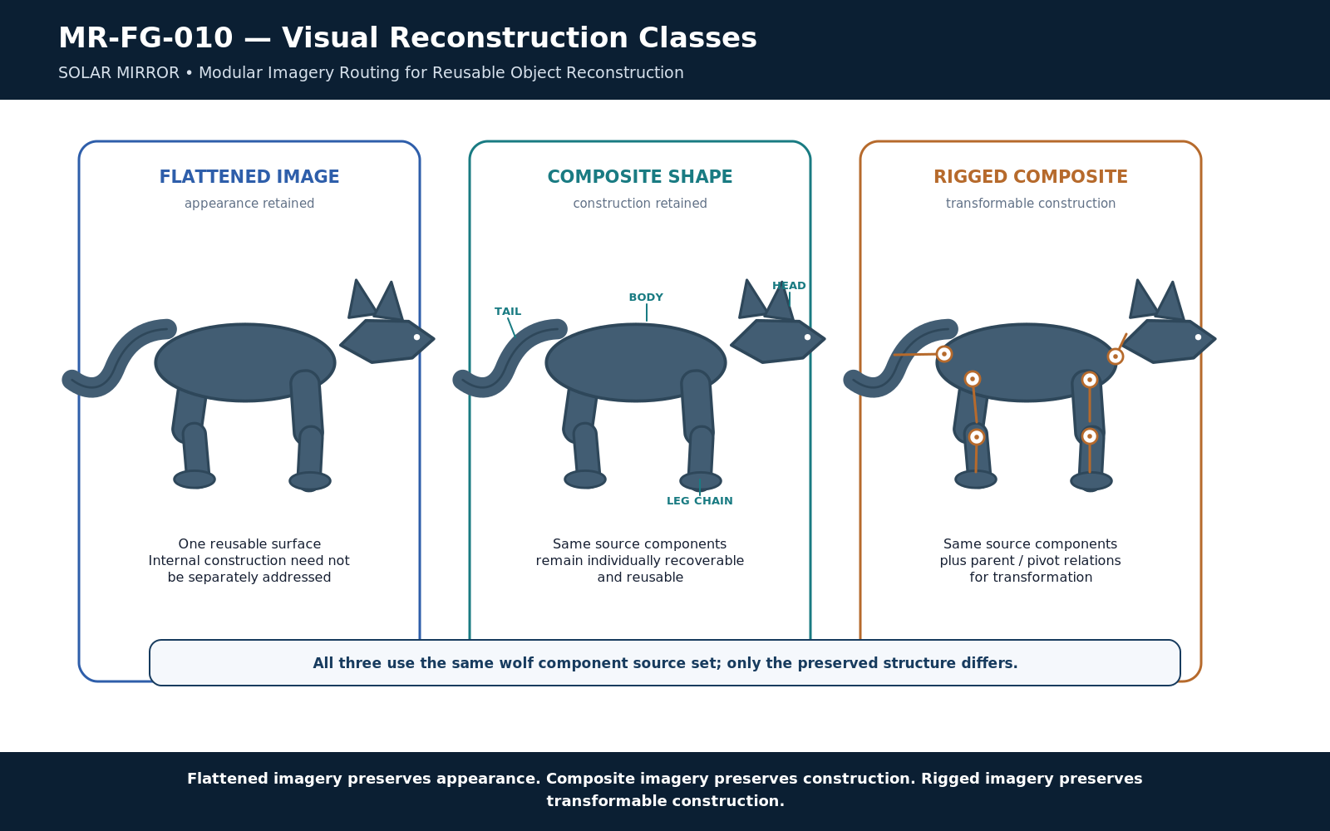
Figure 10. Visual reconstruction classes.
Flattened imagery preserves appearance; Composite imagery preserves construction; Rigged imagery preserves transformable construction.
Class | Preserves | Typical Use
Flattened Image | Appearance | Immediate illustration, photograph, reference, texture, finished visual.
Composite Shape | Recoverable construction | Reusable object assembled from addressable components.
Rigged Composite | Transformable construction | Composite whose parent, pivot, or transform relationships support controlled pose or configuration changes.

These classes are not a quality hierarchy. A flattened photograph may be exactly right for a publication; a Rigged Composite may be unnecessarily complex. MIRROR preserves the form whose recoverability matches the expected reuse.

23. Layered Object Reconstruction
A layered object stores separable visual parts rather than only the final appearance. A wolf can preserve Body, Head, Ear, Upper Leg, Lower Leg, Paw, and Tail as reusable parts. A reconstruction manifest can then describe parent, attachment point, pivot, z-order, default transform, rotation limits, scale, visibility, or other relationships required to reproduce the object.

24. Wolf Asset Territory
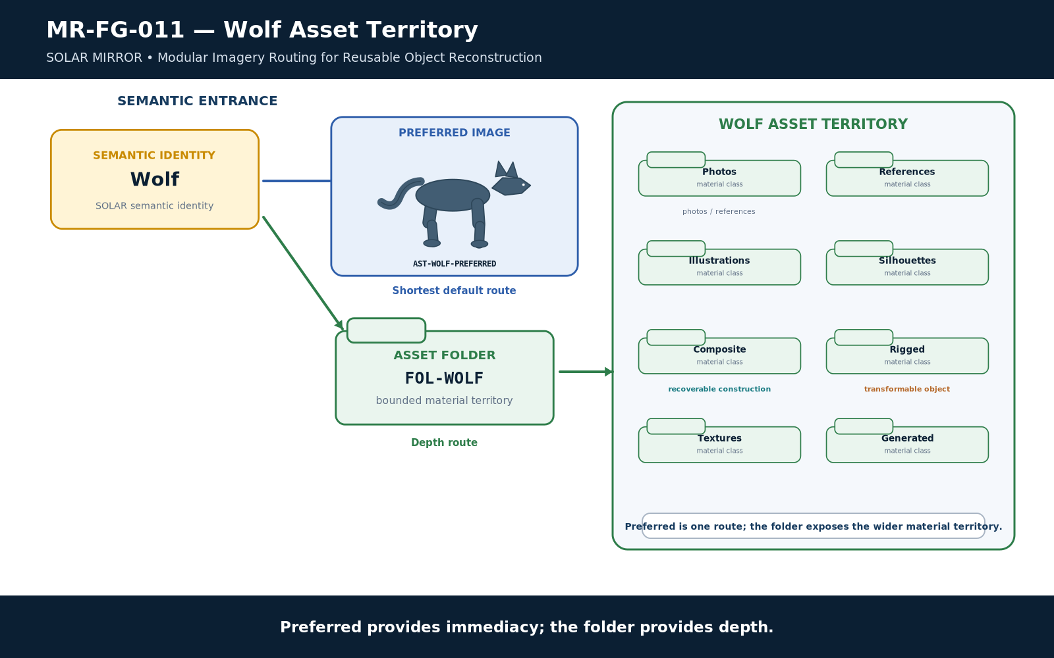
Figure 11. Wolf asset territory.
Preferred provides immediacy; Asset Folder provides depth.
Wolf is the flagship direct-routing example because it has no reason to exist as a formal CERBERUS system component simply to support imagery. SOLAR can give Wolf one Preferred Image for immediate use and one Asset Folder for deeper exploration. The folder may contain photographs, references, illustrations, silhouettes, composites, rigs, textures, generated candidates, and later human-edited variants.
PREFERRED VS. AVAILABLE
Preferred Image is the shortest default route. Asset Folder is the deeper explorable territory. Preferred never means exclusive.

25. Wolf Reusable Object Reconstruction
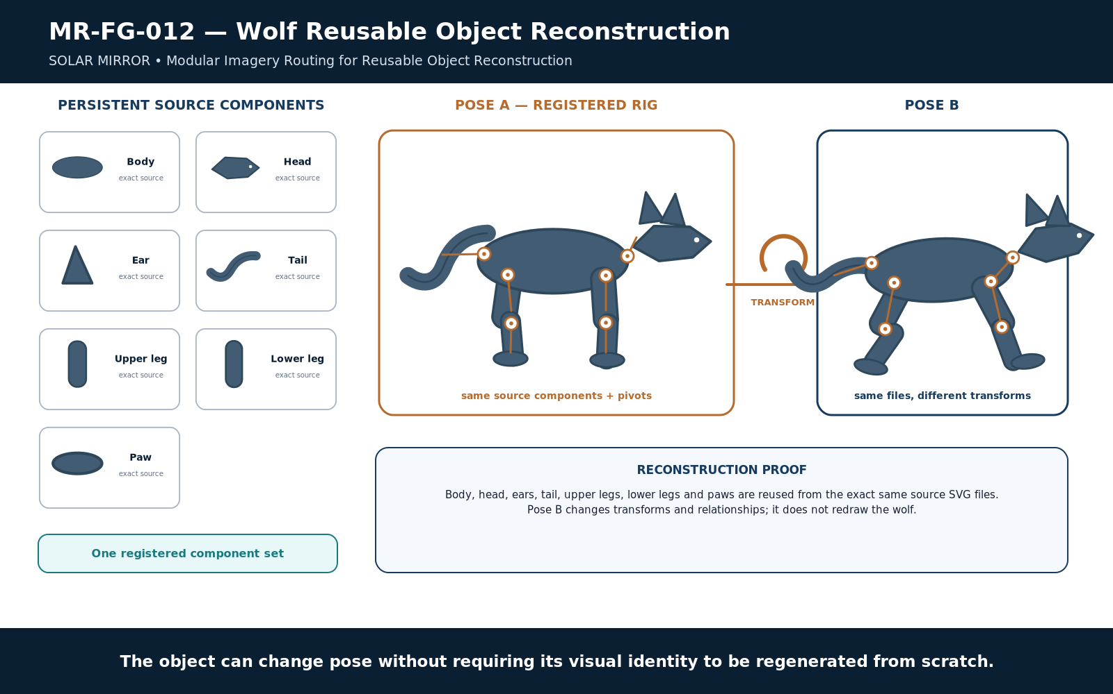
Figure 12. Wolf reusable object reconstruction.
The same registered wolf parts support multiple poses through transforms rather than redrawing.
The wolf demonstrates the defining difference between regeneration and reconstruction. If the same registered head, torso, ear, limb, paw, and tail assets can be reused under different transforms, the system can create a new pose without asking a generator to approximate the wolf again from scratch.
The Figure program itself was built according to this rule: the second wolf pose reuses the same registered component SVGs as the first pose, with transforms and relationships changed rather than the animal being redrawn. The architecture is therefore demonstrated by the production artifact, not merely described in prose.

26. Tree as Mixed Material Reconstruction
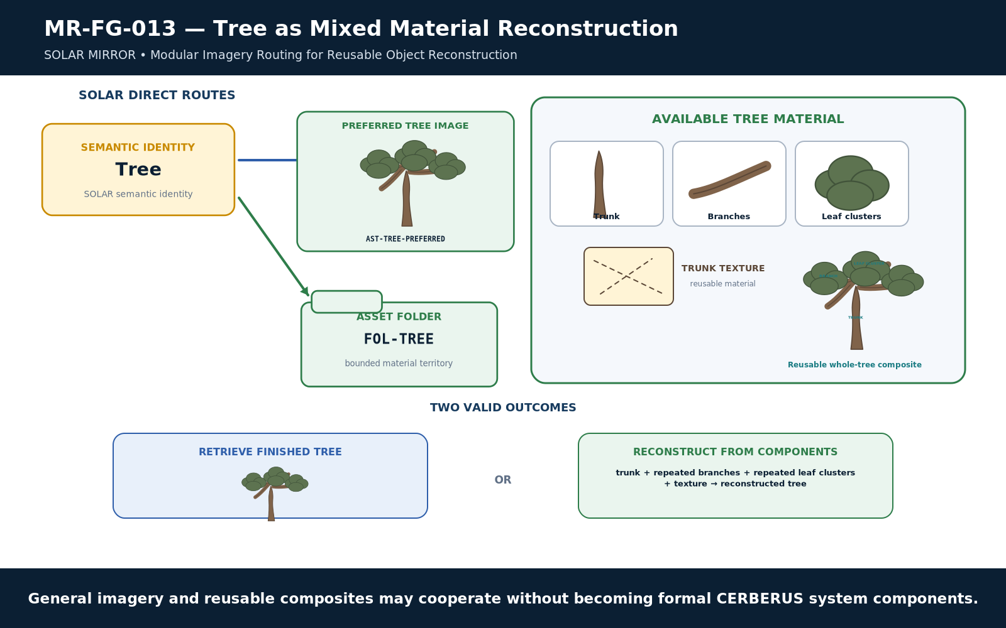
Figure 13. Tree as mixed material reconstruction.
General imagery and reusable composites can cooperate without becoming formal CERBERUS system components.
Tree shows how ordinary imagery and reusable construction can coexist. A task may retrieve a finished tree image directly, or it may reconstruct a new tree from reusable trunk, branch, leaf, and texture material. None of those assets needs to become a formal CERBERUS system component. MIRROR supplies material reachability while semantic ownership remains elsewhere.

27. Transforming Existing Material
Transformable reconstruction can include rotation, translation, scaling, visibility changes, layering, texture substitution, or other bounded operations. MIRROR does not itself need to be the animation engine. Its architectural responsibility is to preserve enough recoverable structure that a downstream renderer, rigging system, or document builder can perform those operations without recreating the source object.

28. Reuse Before Recreation
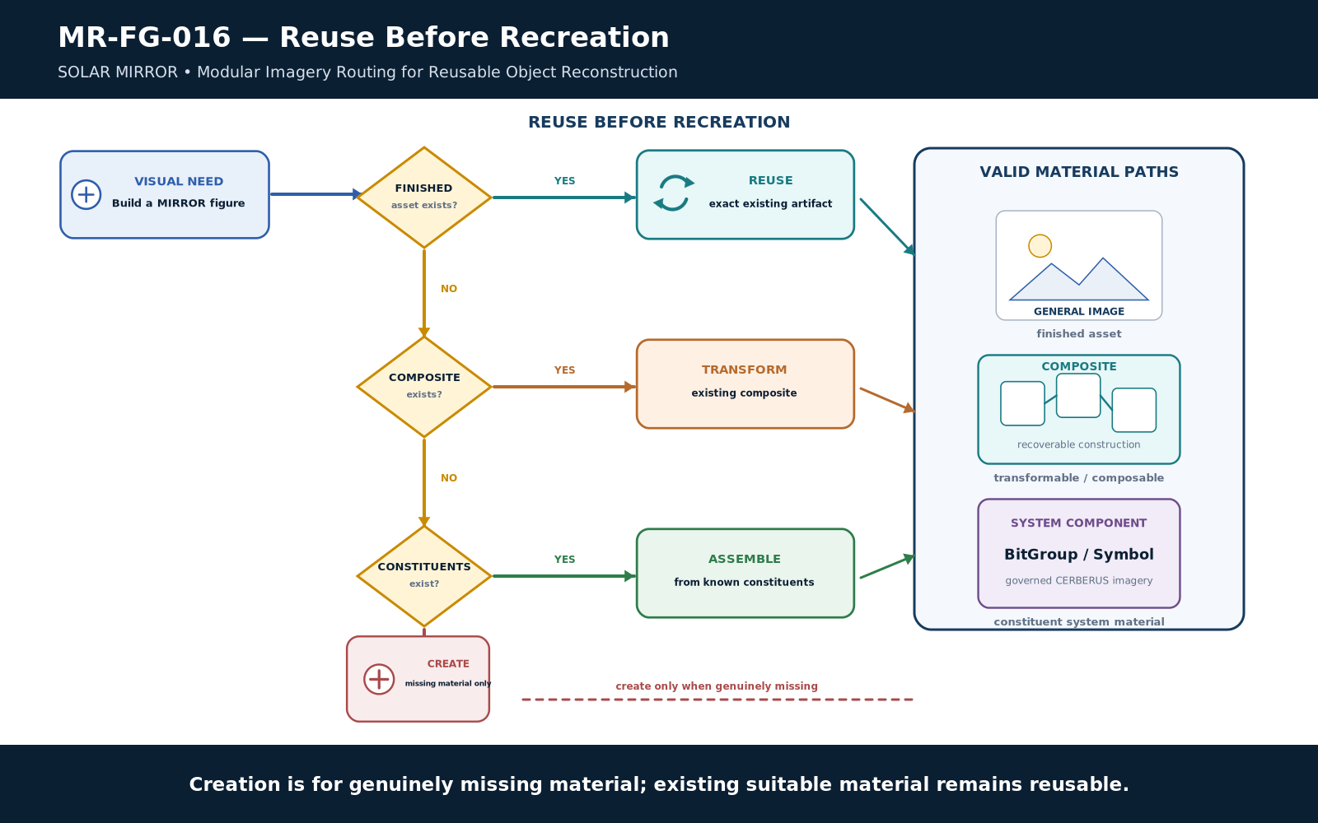
Figure 16. Reuse before recreation.
Use a finished asset when suitable, reconstruct from existing structure when possible, and create only genuinely missing material.
When a visual need arises, the material search should preserve existing value. A suitable finished asset can be reused. If the finished state is wrong but a suitable Composite exists, it can be transformed or reconstructed. If only constituents exist, those can be assembled. Creation is reserved for genuinely missing material.
RECONSTRUCTION PREFERENCE
Existing suitable material should remain discoverable before equivalent material is recreated.

29. Reconstruction Versus Regeneration
Mode | Definition | Consequence
Reconstruction | Assemble or transform known reusable material whose identities and relationships are already available. | Preserves continuity, editability, repeatability, and accumulated visual decisions.
Regeneration | Create a new approximation of the requested appearance from instructions or prompting. | May be useful for gaps, but can discard exact prior visual decisions unless the result is captured and registered.

MIRROR does not prohibit generation. It changes generation from the default behavior into one material-source option. Once a generated result is accepted, edited, or decomposed into reusable parts, it can enter MIRROR and become reconstruction material for later tasks.

30. CERBERUS Technical Figure as Mixed Reconstruction
The same principles apply to technical documentation. A publication figure can combine exact System Components, reusable Composite Shapes, and a general image when appropriate. The document builder can therefore work at the highest reusable level available instead of redrawing every arrow, token, symbol, or component for each paper.
PART 4 - How MIRROR Grows and Remains Governed
Human selection and editing enrich the material layer while semantic ownership and downstream workflow boundaries remain explicit.

31. Human Modification Is First-Class
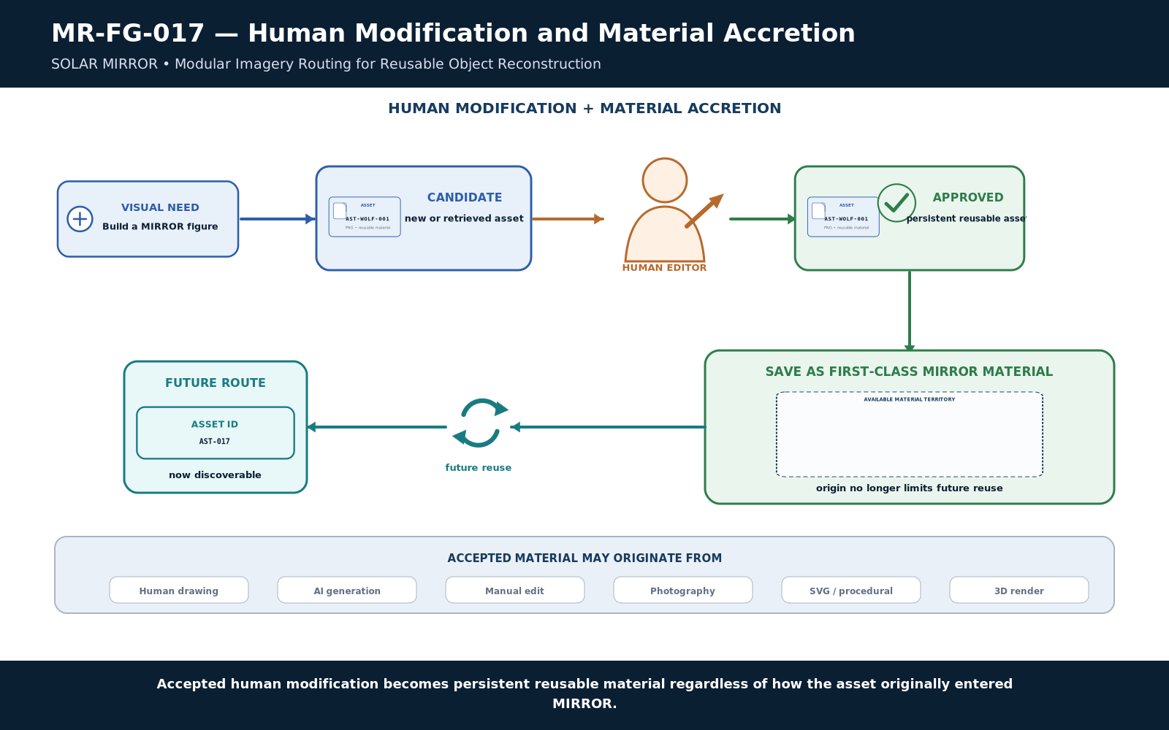
Figure 17. Human modification and material accretion.
Accepted human modification re-enters MIRROR as ordinary reusable material and increases future reconstruction capacity.
MIRROR is origin-agnostic. A useful asset may begin as a photograph, hand drawing, AI generation, procedural SVG, Blender render, scanned sketch, or other source. A human can then edit it, replace layers, adjust proportions, recolor it, or choose one version over another. Once accepted, that edited artifact can become the normal reusable material for future tasks.
This is crucial for persistence of preference. A future AI need not know the exact prompt that once produced a character face or wolf body. It can retrieve the accepted artifact itself. The library therefore captures visual decisions rather than only the instructions that originally produced them.

32. Material Accretion
Each successful reconstruction can enrich the library. If a task discovers a missing paw layer, creates it, and preserves it as a reusable component, later tasks inherit that new capability. If a Composite is repeatedly assembled, an approved assembled version can itself become a reusable higher-level asset. The material graph gains depth through use.
MATERIAL ACCRETION LAW
Approved new visual material should increase future reconstruction capacity rather than remain isolated to one output.

33. Persistent Visual Memory
MIRROR functions as persistent visual memory because the exact artifact survives beyond the conversation or production session that created it. The system can remember a chosen silhouette, a manually corrected diagram primitive, a character face, a layered rig, or a preferred technical token by retaining the artifact and its route rather than trying to infer the old visual decision later.

34. Material Updates Without Semantic Mutation
Updating an asset should not silently mutate the semantic object it represents. A Preferred Image can change while Wolf remains Wolf. A new BitGroup SVG can replace an old rendition while the BitGroup identity and composition remain governed by BIGFOOT. Material versioning and semantic versioning may interact, but they are not the same event.

35. MIRROR Ownership Boundaries
MIRROR may preserve representations of semantic identities without becoming their owner. It may store the exact system imagery of a BitWord without deciding what the BitWord means. It may store a BOSS symbol without becoming the symbolic registry. It may expose material associated with a DARTBOARD Target without becoming runtime authority.
OWNERSHIP BOUNDARY
MIRROR preserves and resolves material representations. CERBERUS systems remain authoritative for the identities, semantics, rules, and state those materials represent.

36. Missing-Material Conditions
A missing Preferred Image is not an error. A missing Asset Folder is not an error. A direct route may be blank while inherited System Component assets remain available. Conversely, a concept may have no reusable material anywhere. MIRROR should represent these states explicitly rather than fabricating false availability.
Condition | Meaning | Appropriate Response
Preferred blank | No default visual is registered. | Search folder or inherited territory if the task needs imagery.
Folder blank | No direct material territory is registered. | Use Preferred or inherited material if available.
Direct routes blank | SOLAR has no direct MIRROR material route. | Traverse existing CERBERUS graph as applicable.
No suitable material | The current library cannot satisfy the reconstruction. | Create or acquire only the genuinely missing material, then register it if accepted.

37. Complete SOLAR MIRROR Architecture
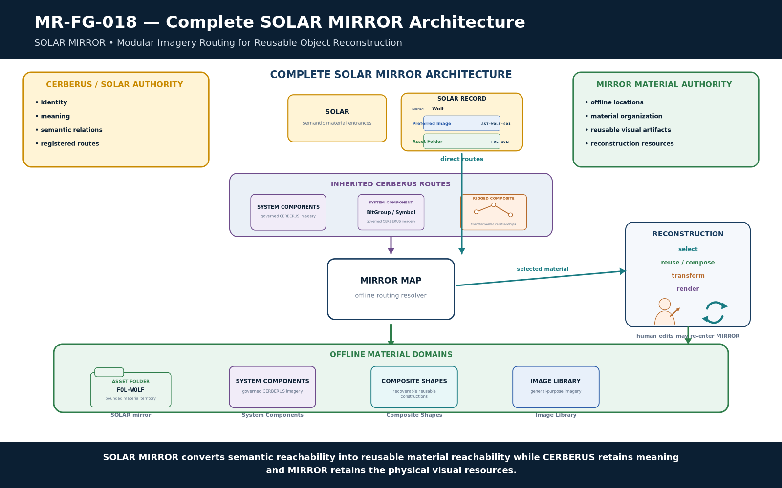
Figure 18. Complete SOLAR MIRROR architecture.
SOLAR MIRROR converts semantic reachability into material reachability while CERBERUS retains semantic authority.
The complete architecture starts with governed semantic identity in CERBERUS and lexical entry through SOLAR. Direct routes expose Preferred Image and Asset Folder; inherited routes expose material through existing graph relationships. MIRROR_MAP resolves logical routes into the offline library regions. The consumer retrieves, composes, transforms, or reconstructs material as needed. Human-approved changes can return to the material layer while semantic authority remains with the original owners.
SYSTEM COMPRESSION
SOLAR MIRROR converts semantic reachability into reusable material reachability while CERBERUS retains meaning and the offline library retains the physical visual resources.

38. Boundary to Future OctoGroove Integration
This paper defines MIRROR itself. It does not redefine OctoGroove. A later integration paper can specify how Pass 5 searches MIRROR, how Pass 6 retrieves and composes registered artifacts, how candidate upgrades are recommended, how new assets are admitted, and how Pass 8 validates asset lineage and hashes. Keeping that workflow downstream protects MIRROR as a general material architecture usable by document production, SK builders, characters, scenes, rigs, interfaces, and other future systems.
The dependency direction is therefore deliberate: define MIRROR, build the offline library and routing map, then upgrade OctoGroove and other consumers to use it. MIRROR remains the material substrate; each downstream workflow decides how to search and govern it.
APPENDIX A - Normative MIRROR Laws
The following laws compress the architecture into implementation constraints.

Law | Name | Normative Statement
MR-R01 | Semantic/Material Separation | Semantic identity and physical visual material SHALL remain independently governed.
MR-R02 | Optional Direct Route | A SOLAR record SHALL NOT be required to possess a Preferred Image or Asset Folder.
MR-R03 | Preferred Image | Preferred Image SHALL identify a default visual route, not a semantic definition or exclusive asset.
MR-R04 | Asset Territory | Asset Folder SHALL identify an entry into offline material territory whose internal complexity may exceed SOLAR's knowledge.
MR-R05 | Blank Route | A blank direct route SHALL be valid and SHALL NOT imply the absence of inherited material.
MR-R06 | Inherited Material | Assets exposed through linked CERBERUS structures may participate in MIRROR discovery without transferring ownership to MIRROR.
MR-R07 | Many-to-Many Asset | Semantic identities and visual assets SHALL NOT be assumed to have a one-to-one relationship.
MR-R08 | Single Artifact Reuse | A reusable physical artifact SHOULD be stored once and routed from multiple relevant semantic identities where practical.
MR-R09 | SOLAR Mirror Fidelity | The SOLAR branch SHALL preserve routability to SOLAR semantic territory without becoming an independent semantic authority.
MR-R10 | System Component Fidelity | System-component imagery SHALL remain traceable to the registered CERBERUS structure it represents.
MR-R11 | Recoverable Composition | Composite Shapes SHALL preserve sufficient information to recover or address their reusable constituents.
MR-R12 | Transformable Reconstruction | Rigged composites SHALL preserve sufficient relational information to permit governed transformation of their components.
MR-R13 | Folder Opacity | SOLAR SHALL route to asset territory without encoding its complete internal filesystem topology.
MR-R14 | Physical Location Independence | MIRROR routes SHOULD remain portable across storage devices and machines rather than depending on absolute machine-specific paths.
MR-R15 | Identity-First Retrieval | Consumers SHOULD resolve relevant material identities or routes before loading full binary assets where practical.
MR-R16 | Reuse Before Recreation | Existing suitable material SHOULD remain discoverable for reuse or reconstruction before equivalent material is recreated.
MR-R17 | Human Modification Persistence | Human-edited or human-selected material MAY become the reusable active artifact regardless of its original production method.
MR-R18 | Material Accretion | Approved new visual material SHOULD increase future reconstruction capability rather than remain isolated to one output.

APPENDIX B - Reconstruction Tests
A fresh assistant should be able to recover these answers from the paper without outside explanation.

Question | Expected Reconstruction
What is SOLAR MIRROR? | Offline visual-material routing and reconstruction layer associated with SOLAR.
Why is MIRROR separate from SOLAR? | SOLAR retains semantic/lexical authority; MIRROR retains material routes and physical artifacts.
What is Preferred Image? | Optional default visual route; preferred is not exclusive.
What is Asset Folder? | Optional entrance into arbitrarily complex offline material territory.
Can either field be blank? | Yes. Both independently support blank as a valid state.
What happens when both are blank? | No direct route is registered; inherited CERBERUS material may still be reachable.
What is inherited routing? | Material exposed through existing linked CERBERUS structures such as BIGFOOT or BOSS.
Why can many concepts use one image? | Asset identity and semantic identity are independent; reuse does not merge meaning.
Why can one concept use many images? | Different visual roles, formats, references, composites, and variants can serve the same semantic object.
What are the three reconstruction classes? | Flattened Image, Composite Shape, Rigged Composite.
What does MIRROR_MAP do? | Resolve logical material identities and routes into the current physical folder and file graph.
Why avoid absolute paths in SOLAR? | Logical routes remain portable when the library root or storage device changes.
How can a wolf change pose without regeneration? | Reuse the same registered component assets under different transform relationships.
How does human editing fit? | Accepted edits become normal persistent reusable material.
What does MIRROR own? | Material organization, reusable artifacts, composite resources, and offline routing metadata.
What remains owned by CERBERUS? | Semantic identities, meanings, relationships, rules, and authoritative state.

APPENDIX C - Figure Index and Implementation Handoff
The figure program is the visual reconstruction interface; implementation remains downstream of this architecture paper.

Fig. | Title | Architectural Role
1 | SOLAR MIRROR thesis | Meaning resolves to routes; routes resolve to reusable material; reusable material supports reconstruction.
2 | Semantic identity, asset, and physical location | Semantic Identity, Visual Asset, and File Location remain separate identities.
3 | Two direct SOLAR fields | Preferred Image and Asset Folder are independent optional direct routes; blank is valid.
4 | Direct and inherited material routing | Direct SOLAR routes and inherited CERBERUS routes contribute to the same available material horizon.
5 | Available material territory | MIRROR exposes heterogeneous material territory rather than forcing one mandatory file.
6 | MIRROR root architecture | The root separates semantic entrances, governed system imagery, reusable constructions, general imagery, and routing metadata.
7 | SOLAR Mirror and folder opacity | SOLAR knows where material territory begins without encoding the territory's internal filesystem topology.
8 | BIGFOOT inherited asset traversal | Higher-order BIGFOOT structures can expose both assembled imagery and reusable imagery from their constituents.
9 | Many-to-many asset binding | Many semantic identities may share one asset, and one semantic identity may expose many or no assets.
10 | Visual reconstruction classes | Flattened imagery preserves appearance; Composite imagery preserves construction; Rigged imagery preserves transformable construction.
11 | Wolf asset territory | Preferred provides immediacy; Asset Folder provides depth.
12 | Wolf reusable object reconstruction | The same registered wolf parts support multiple poses through transforms rather than redrawing.
13 | Tree as mixed material reconstruction | General imagery and reusable composites can cooperate without becoming formal CERBERUS system components.
14 | MIRROR_MAP routing and portability | Logical MIRROR routes remain stable even when the physical storage root changes.
15 | Identity-first retrieval | Reason over identities and routes first; retrieve binaries only when reconstruction requires them.
16 | Reuse before recreation | Use a finished asset when suitable, reconstruct from existing structure when possible, and create only genuinely missing material.
17 | Human modification and material accretion | Accepted human modification re-enters MIRROR as ordinary reusable material and increases future reconstruction capacity.
18 | Complete SOLAR MIRROR architecture | SOLAR MIRROR converts semantic reachability into material reachability while CERBERUS retains semantic authority.

Implementation Handoff
The next implementation project can create the actual SOLAR_MIRROR filesystem, MIRROR_MAP workbook, and the two direct SOLAR fields. That build should treat this paper as the architecture contract while leaving exact workbook columns, filesystem-safe naming rules, asset IDs, supported formats, and lifecycle automation open to implementation-level refinement.
After the library exists, the later OctoGroove integration paper can define the governed production workflow that searches, reuses, upgrades, registers, and verifies MIRROR assets. This preserves the intended dependency direction: MIRROR first, consumers second.
BUILD ORDER
Define the material architecture. Build the library and resolver. Then teach OctoGroove, SK builders, and other consumers how to use it.

Final Compression
SOLAR MIRROR is Modular Imagery Routing for Reusable Object Reconstruction. SOLAR provides semantic entrances; MIRROR provides persistent routes from those entrances into offline visual material. Each SOLAR record may optionally expose a Preferred Image and an Asset Folder, while existing CERBERUS links may expose inherited system-component assets. MIRROR organizes these routes across a SOLAR mirror, governed System Components, reusable Composite Shapes, and a general Image Library, with an offline map resolving the physical folder graph. Assets may be shared by many semantic identities, and identities may expose many or no assets. Composite and rigged material preserve reusable construction so known objects can be transformed and reconstructed rather than repeatedly regenerated. CERBERUS retains semantic authority; MIRROR retains the reusable material reflection.

